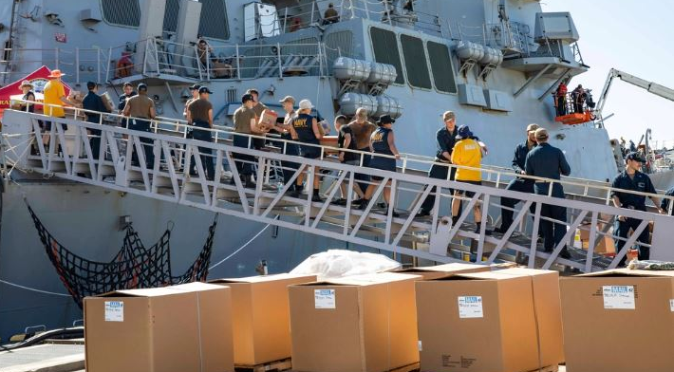
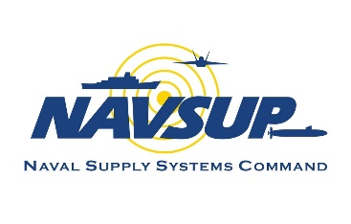
Supply Corps Team,
OP Monthly
March 2024

In this month’s edition, we are ‘springing’ into discussions on the Operational Logistics Planning competency and its importance to our ever-changing global environment. The Supply Corps will be at the forefront of supporting the warfighting operations, ensuring the effectiveness of the Navy’s maritime advantage as we shift towards a new operational posture. As part of this competency, we highlight a location that is on the forefront of our Pacific operation.

First and foremost, however, we would like to provide updated guidance for the Training With Industry program. This spring also brings preparations for the Commander Milestone board, which has new and upcoming guidance. We will also provide an update to the orders release posture, discuss more records management tips, give information about the BRS-Continuation Pay, and highlight the spring internship cycle.

Thank you for everything that you do.

CAPT Alsandro H. (Jay) Turner
Director, Supply Corps Personnel

New and Noteworthy…

Training With Industry - Correction

In last month’s edition of the OP Monthly, we provided an update to the Training With Industry (TWI) program that stated that only officers with DFSP experience were eligible for the ExxonMobil. That was incorrect.

ExxonMobil candidates must have experience in Petroleum, Oil, Lubricants (POL) operations (represented by subspecialty 1307S/R/Q) or have earned that experience prior to their Projected Rotation Date (PRD). Graduates from the 811 program, with at least one fuels experience tour (represented by subspecialty 1307S/R/Q), are also eligible for the ExxonMobil fellowship. DFSP experience is not required.

Competency in the Spotlight: Operational Logistics Planning
“The threats to our nation and our interests are real and growing. The strategic environment has changed; gone are the days of operating from a maritime sanctuary against competitors who cannot threaten us. We must move rapidly to stay ahead and continuously create warfighting advantages.”
~Admiral Lisa Franchetti, Chief of Naval Operations
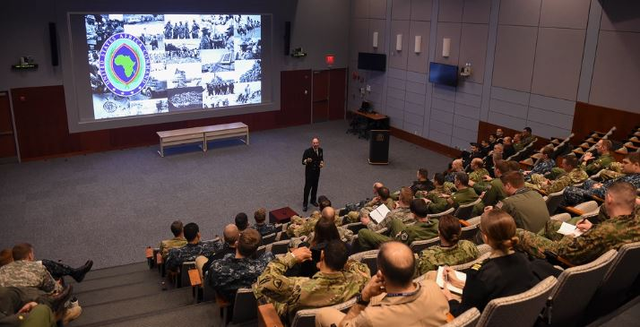
Overview
Supply Corps officers serving as Logistics Planners play an integral role in ensuring the effectiveness of U.S. forces operating in a new, strategic environment. Distributed Maritime Operations place an importance on well-qualified, highly-skilled Operational Logistics Planners who can incorporate logistics and sustainment strategies with other warfighting functions to provide warfighting advantages for Fleet Commanders.

A planner’s primary responsibility is to evaluate operations, offering flexible, survivable, and resilient logistics and sustainment strategies across the competition-crisis-conflict continuum. These roles entail constant exploration of innovative methods and alternative locations for delivering essential combat sustainment. This enhances our maritime advantage and fortifies our logistics and sustainment capacity and effectiveness.

Click to learn more about Operational Logistics Planning. . .

Planners craft and implement actionable plans, including Operation Plans (OPLANs), Concept Plans (CONPLANs), Operation Orders (OPORDs), Concepts of Logistic Support (COLS), Logistic Sustainability Analyses (LSAs), as well as real-world logistics for Field Training Exercises (FTXs). This is done by innovating within our Naval Logistics Enterprise through table-top exercises, collaborative-virtual exchanges, and proof-of-concept scenarios with allied nations.

Becoming a Planner
Planners are developed via the following opportunities:
- Maritime Advanced Warfighting School (MAWS) – JP1 AQD & 2000P subspecialty
- Maritime Officers Planning Course (MOPC) – JPM AQD
- Master’s degree from an intermediate service college – JPN AQD and 2000P subspecialty
- Experience in a Joint and Maritime Operational Planner (JP3) billet – JP2/3

For more information, contact LT Austen Lauricella, Operational Logistics Planner, COMLOG WESTPAC/CTF-73 at austen.j.lauricella.mil@us.navy.mil.

Location in the Spotlight: Singapore – COMLOGWESTPAC/CTF-73

Location

Singapore is a modern, vibrant city-state with one of the highest per capita GDPs, state of the art public infrastructure to support a population of 5.4 million, and the Changi International Airport that is routinely voted the #1 airport in the world.

A true melting pot, Singapore prides itself on preserving and celebrating the diverse range of cultures, ethnicities, and religions that are embraced by its residents. Each community cherishes unique festivities, traditions, and practices that they celebrate and share. Whether celebrating the Chinese New Year in Chinatown, strolling through the thriving Botanical Gardens, enjoying a meal at Newton Hawker Centre, or shopping at the Mustafa Centre in Little India, there is always something to do, eat, and enjoy.

While there is no United States “base” in Singapore, U.S. Navy personnel have been present since 1968. In 1990, a Memorandum of Understanding was signed to allow the U.S. Navy to permanently assign approximately 150 uniformed and civilian personnel in Singapore. Today, the U.S. military community in Singapore has grown to more than 1,000 active duty military, federal civilians, and their families across 22 tenant commands.

Mission

In Singapore, Supply Corps officers serve in a variety of commands, with the majority assigned to Commander, Logistics Group Western Pacific (COMLOGWESTPAC) and Commander Task Force 73 (CTF-73). COMLOGWESTPAC/CTF-73 is a ‘dual hatted’ command that reports to Commander, Pacific Fleet (PACFLT) to carry out logistics plans, policy, and regional security cooperation responsibilities while also serving as the executive agent for Pacific Partnership. This partnership is an annual multilateral humanitarian assistance and disaster relief preparedness mission, conducted in the Indo-Pacific region. CTF-73 reports to Commander, U.S. Seventh Fleet in employing tactical control authority of approximately 50 Military Sealift Command ships and Fleet Air Western Pacific aircraft in support of fleet operations. CTF-73 serves as lead task force for diving, salvage, and towing.

Click to learn more about the mission and opportunities within COMLOGWESTPAC AND CTF-73. . .

COMLOGWESTPAC/CTF-73 commands, controls, and coordinates theater logistics and sustainment in the performance of the ‘6 R’s’ — Resupply, Refuel, Rearm, Repair, Revive, and Redistribute — to conduct Distributed Maritime and Expeditionary Advanced Based Operations and coordinate the resupply of food, ordnance, fuel, and repair parts for U.S. Navy ships. Additionally, they support allied and partnered vessels that are deployed or operating in the 7th Fleet area of responsibility. The area spans 48 million square miles of the Pacific and Indian Oceans, stretching from the International Date Line to the tip of India, and from the Kuril Islands in the north to the Antarctic in the south. COMLOGWESTPAC/CTF-73 strives to meet the ever-growing demands of distributed maritime logistics in an exciting and dynamic operational environment.

Responsibilities

An assignment at COMLOGWESTPAC/CTF-73 is challenging, especially with the rise of China and Russia in the Indo-Pacific. Supply Corps officers assigned to COMLOGWESTPAC/CTF-73 routinely plan, schedule, and execute sustainment for Seventh Fleet operations. Staff also participate in numerous exercises and operations that span the operational and tactical levels of war.

Opportunities to Gain Valuable Experience
- A deep understanding of geopolitical and national security affairs in the DoD’s priority theater
- Logistics and Operational Planning experience, working with allies and partners
- Dynamic, multifunctional network among Seventh, Fifth and Third Fleet staffs as well as PACFLT and U.S. Indo-Pacific Command

To learn more about Singapore, contact LT Chelsea Rowan (chelsea.m.rowan.mil@us.navy.mil), LT Landon Ostlie (landon.m.ostlie.mil@us.navy.mil), and LTJG Kennedy Robertson (kennedy.m.robertson.mil@us.navy.mil); logistics planners at COMLOGWESTPAC.

Commander Milestone and Command Oral Board
Commander Milestone and Command Oral Board Season is upon us! This year’s CDR Milestone and Command Screening Board (#055) is scheduled to convene 17 June 2024. To be screened during the CDR Milestone and Command Screening Board, a 2D1 AQD (CMD Eligible) is required to be in your record.

Review the governing instruction, NAVSUPINST 1412.1D. We anticipate that NAVSUPINST 1412.1E will be signed soon and will be published on the Supply Corps’ MyNavy HR Instructions page. Coordinate scheduling of a 2D1 Oral Board with the Executive Officer of a NAVSUP Fleet Logistics Center (FLC) in your region.

Click to see FLC POCs and the deadline for 2D1 submission. . .

FLC Bahrain CDR John Bing john.r.bing.mil@us.navy.mil

FLC Jacksonville CDR Jason Revitzer jason.l.revitzer.mil@us.navy.mil

FLC Norfolk CAPT Mordocai Kiflu mordocai.kiflu.mil@us.navy.mil

FLC Pearl Harbor CAPT Ty Luster taquina.t.luster.mil@us.navy.mil

Starting May CDR Bryce Hicks bryce.b.hicks.mil@us.navy.mil

FLC Puget Sound CDR Brian Hays brian.h.hays.mil@us.navy.mil

Starting May CDR Gina Slaby gina.m.slaby.mil@us.navy.mil

FLC San Diego CDR Joe Smutz joseph.a.smutz.mil@us.navy.mil

Starting May CDR Jason Pirrallo jason.a.pirrallo.mil@us.navy.mil

FLC Sigonella CDR Ed Windas edward.p.windas.mil@us.navy.mil

FLC Yokosuka CAPT (Sel) John Tamez john.tamez4.mil@us.navy.mil

The deadline for submission of all Oral Board recommendation letters to the Supply Corps Career Counselor is 31 May 2024. For any questions, reach out to LCDR Matt Wall at kevin.m.wall10.mil@us.navy.mil. Best of luck while preparing for this important career milestone!

What’s the Status of My Orders?

Congress has passed several continuing resolutions (CRs) that extend FY24 funding. The latest is set to ‘expire’ on March 22nd.
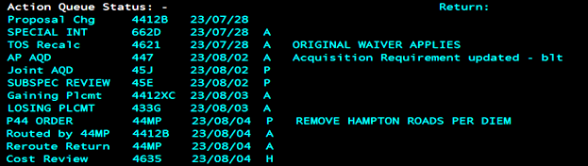

While we are accustomed to the release of orders between four to six months ahead of the expected detachment, all orders beyond May 2024 are at a stand-still – both CONUS and OCONUS. The exception is accessions, retirements, and separations, which are extended to November 2024. If you are within four months of your detachment, reach out to your detailer to obtain a Letter of Intent to begin any administrative processes. We appreciate your continued patience and hope for a resolution soon!

From the Career Counselor Team
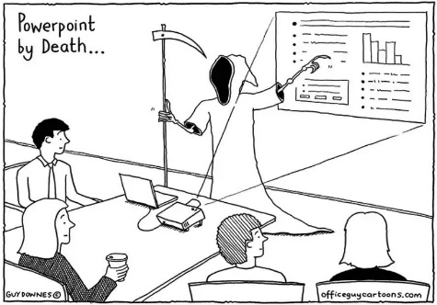
At a minimum, Supply Corps officers should have BQC and Basic Leadership in Block 52, for service schools of the Officer Data Card (ODC). While there is a maximum space for six total service schools, a complete listing of can be found in the NOOCS Manual, Volume II, Appendix C. After identifying the code for your service school, request record entry through MyNavy Career Center (MNCC).

Once the school has been entered to your ODC, it will automatically update your Officer Summary Report (OSR). Unfortunately, the Career Counselor team does not have the ability to update service schools on a member’s record.

Click to learn how to request record entry of service schools. . .

Email MNCC at askmncc.fct@navy.mil with the below statement, attaching a copy of your Joint Service Transcript or the Certificate of Completion. If you do not receive a response email, contact MNCC to get the ticket number, which is needed for tracking purposes.

“Dear MNCC,

Please update Block 52 of my ODC with the following Service School(s). My Joint Service Transcript/Certificate of Completion is attached for your reference.

Course Title: ________ (per NOOCS Manual)

School Location: ________

Completion Date: ________

Course Duration: ________ (weeks)

3-Digit School Code: ________ (per NOOCS Manual)

I can be reached at ________@navy.mil if you have any questions. Thank you for your assistance.”

Note: If the school in question is not listed in the NOOCS Manual, it cannot go on your ODC. For example, there is not code for attending the Executive Development Program (EDP), the Advanced Management Program (AMP), the LogTech Program, or any UVA Darden Courses. Utilize verbiage within Block 41 of your FITREP to show that these courses were attended during the reporting period.

Contact Information Update

All officers who will promote or are in-zone for promotion during FY25 should reach out to the Career Counselor to ensure that their contact information is up-to-date.

For all other personnel, NAVSUP OP periodically sends information regarding boards, graduate education opportunities, helpful reminders, the OP Monthly, etc. It is essential that you update your contact information with the Career Counselor team after completing a move.

Reserve Component officers, update your contact information via the ‘Update Personal Information’ section on Navy Standard Integrated Personnel System (NSIPS).

Blended Retirement System – Continuation Pay
The Blended Retirement System’s (BRS) Continuation Pay (CP) is designed as a mid-career retention incentive. It is payable between the completion of 8 and 12 years of service. Continuation pay will vary by individual but will generally range between $21,000 (eight years of commissioned service, eight total years of service) and $23,000 (12 years of commissioned service, 20 years of total service) for Supply Corps officers. Service members opting to take continuation pay incur an additional four years of service obligation10.

Click to learn about the BRS-CP eligibility and obligation requirements. . .

Eligibility:
- Active and TAR members covered under the BRS with less than 12 years of service, as computed from the member’s pay entry base date (PEBD)
- Reserve members who have less than 12 years of service, as computed from the member’s PEBD, and is a member of the Selected Reserves (SELRES) or in the Individual Ready Reserves (IRR) in which the member is eligible to receive basic pay or inactive duty pay for four years

Note: Members with separation orders, a submitted request to separate, have over 12 years of service, or have previously received Continuation Pay are not eligible. Opting in to BRS CP incurs a payback obligation of four years, which runs concurrently with any other service obligations. For additional information or pay rates, review MILPERSMAN 1810-081 and NAVADMIN 118/23.

Spring 2024 Internship Screening
NAVSUP OP is accepting packages for the spring 2024 internship screening! The deadline for submission is Friday, 29 March 2024. Program and billet list updates are available on the MyNavy HR Supply Corps Internship page.
Eligibility Requirements:
- 3100 or 6510 ENS – LT
- Earned bachelor’s degree
- Successful completion of (or will complete) one operational tour
- PRD between October 2024 to October 2025 (waivers accepted)

Note: LTs are only considered if participation will not affect their promotion opportunity to LCDR. For more information or to submit a package, contact the Internship Program Coordinator.

2024 Ruehlin Seminar

The Ruehlin Seminar is an Executive Transition Assistance Program (XTAP), which focuses on the practical aspects of career transition. The seminar is provided to senior officers, enlisted personnel (E8/E9), and Warrant Officers who have 20-30+ years on Active Duty and are planning to retire in the next two years. The course is intended for Active Duty Supply Corps personnel and their partners. Travel is self-funded by participants.

Click to see more information about the Ruehlin Seminar. . .

The tentative dates for the two seminars scheduled for FY 24 are:

1. Washington, DC 13-17 May 2024

2. San Diego, CA 5-9 August 2024

Due to limited seating, attendance requests should be submitted NLT six weeks from the seminar start date. If interested in attending an upcoming seminar, contact Ms. Lisa Mobius at lisa.e.mobius.civ@us.navy.mil. Note: The Ruehlin Seminar does not replace the required Transition Assistance Program (TAP) for officer and enlisted personnel separating/retiring from Active Duty.

2024 OP Roadshow

NAVSUP OP is hitting the road and heading your way! The OP Team will present valuable career information, discuss different facets of the Supply Corps community, and conduct one-on-one career interviews.

Note from the Navy Supply Corps Foundation (NSCF): Be sure to update contact information with the local Navy Supply Corps Foundation (NSCF) chapter to receive the latest and greatest information. NSCF chairs, feel free to reach out to the Supply Corps Career Counselor team for assistance to ensure that all member information is up to date.

Click to see the 2023 – 2024 OP Roadshow dates. . .

18 to 22 March Norfolk / Little Creek

1 to 5 April Jacksonville / MacDill AFB

18 to 20 April Fort Worth (Reserve Component)

15 to 24 April Pearl Harbor / Guam

11 to 14 May Reserve Component Virtual

20 to 24 May Bahrain

3 to 7 June Groton / New England

10 to 11 June CONUS Virtual

12 June 6th Fleet Virtual

13 to 15 June 7th Fleet Virtual

*Schedule is subject to change.

Important Links

2024 Supply Corps Directory (CAC-Enabled)

FY 25 Board Schedule

FY 25 Active Duty Promotion Selection Board Zone Message (NAVADMIN 290/23)

FY 25 Reserve Promotion Selection Board Zone Message (NAVADMIN 301/23)

Contact Us

Position | Name | E-mail
Director | CAPT Jay Turner | alsandro.h.turner2.mil@us.navy.mil
Director, Detailing Division | CAPT Dena Risley | dena.b.risley.mil@us.navy.mil
OP Assistant | CDR Travis Miller | travis.m.miller24.mil@us.navy.mil
OP1 Assistant | LCDR K. Matt Wall | kevin.m.wall10.mil@us.navy.mil
Reserve & TAR Director | CDR Eric Gardner | eric.a.gardner5.mil@us.navy.mil
TAR Mgt. Branch Detailer | CDR Treven Feleciano | treven.s.feleciano.mil@us.navy.mil
“Pit Boss”/LCDR Detailer | CDR Dustin Martindale | dustin.r.martindale.mil@us.navy.mil
LT Operational/PG School | LCDR Winston Lamb | winston.c.lamb.mil@us.navy.mil
LT Shore Detailer | LCDR Nicholas Mays | nicholas.c.mays.mil@us.navy.mil
CWO/BQC/Submarine Detailer | CWO5 Benny Brockington | benny.brockington.mil@us.navy.mil
AC Career Counselor | CDR Long Tran | long.k.tran.mil@us.navy.mil
RC Career Counselor | LCDR Bethany Satterwhite | bethany.c.satterwhite.mil@us.navy.mil
Accessions/Internship Officer | LT Lydia Sankey | lydia.j.sankey.mil@us.navy.mil
Director, Supply OCM | CDR Leanne Riley | leanne.r.riley.mil@us.navy.mil
Deputy, Supply OCM | Ms. Beth Schudel | beth.r.schudel.civ@us.navy.mil
Director, Reserve OCM | LCDR Danica Johnson | danica.r.johnson.mil@us.navy.mil

Supply Corps Officer Strength

3100 Active Component
Paygrade | Authorized | Inventory | Gross Over/Under | Non-Distributable Inventory | Total Delta
O-6 | 172 | 165 | -7 | 6 | -13
O-5 | 353 | 343 | -10 | 5 | -15
O-4 | 533 | 491 | -42 | 2 | -44
O-3 | 712 | 619 | -93 | 18 | -111
O-2 | 267 | 296 | 29 | 16 | 13
O-1 | 258 | 291 | 33 | 5 | 28
Totals | 2295 | 2205 | -90 | 52 | -142
Data source: the Officer Inventory / Authorization (Tri-Color) dated 31 January 2024.

Note: Officers selected for promotion in FY23 are listed in their current rank. Officers are detailed to billets in the next higher rank, resulting in lower distributable LT inventory numbers.

3107 Reserve Component –Training and Administration of the Reserves (TAR)
Paygrade | Authorized | Inventory | Delta
O-6 | 8 | 10 | 2
O-5 | 26 | 23 | -3
O-4 | 32 | 39 | 7
O-3 | 26 | 19 | -7
O-2 | 0 | 4 | 4
O-1 | 1 | 1 | 0
Totals | 93 | 96 | 3

3105 Reserve Component (RC) – Selected Reserves (SELRES)
Paygrade | Authorized | Inventory | Delta
O-6 | 52 | 50 | -2
O-5 | 175 | 171 | -4
O-4 | 316 | 299 | -17
O-3 | 176 | 141 | -35
O-2 | 82 | 46 | -36
O-1 | 25 | 77 | 52
Totals | 826 | 784 | -42

3165 RC In-Training
Paygrade | Authorized | Inventory
O-3 | 0 | 0
O-2 | 0 | 4
O-1 | 0 | 68
Totals | 0 | 72

6510 Limited Duty Officer (LDO)
Paygrade | Authorized | Inventory | Gross Over/Under | Non-Distributable Inventory | Total Delta
O-6 | 0 | 0 | 0 | 0 | 0
O-5 | 0 | 0 | 0 | 0 | 0
O-4 | 1 | 0 | -1 | 0 | -1
O-3 | 34 | 16 | -18 | 0 | -18
O-2 | 9 | 11 | 2 | 0 | 2
O-1 | 15 | 16 | 1 | 3 | -2
Totals | 59 | 43 | -16 | 3 | -19

7520 Food Service Warrant
Paygrade | Authorized | Inventory | Gross Over/Under | Non-Distributable Inventory | Total Delta
CWO-5 | 3 | 5 | 2 | 1 | 1
CWO-4 | 10 | 13 | 3 | 3 | 0
CWO-3 | 25 | 23 | -2 | 3 | -5
CWO-2 | 20 | 21 | 1 | 2 | -1
Totals | 58 | 62 | 4 | 9 | -5

Individual Augmentation (IA) Update
There are currently 36 filled Supply Corps IA requirements*:
Active Component (3100, 6510, 7520): 8
Rank | Djibouti | Jordan | Kuwait | Texas | Total
ENS
LTJG | 1 | 1 |  | 1 | 3
LT | 1 |  | 1 | 1 | 3
LCDR | 2 |  |  |  | 2
CDR
CAPT
Total | 4 | 1 | 1 | 2 | 8

Reserve Component (3165, 3105, 3107): 28
Rank | Jordan | UAE | HOA | Bahrain | Kuwait | Germany | Hawaii | Guam | CONUS | Total
ENS
LTJG |  |  | 1 | 1 |  |  |  |  |  | 2
LT | 1 | 1 | 5 | 1 |  |  | 1 |  |  | 9
LCDR |  |  | 4 | 4 | 1 | 1 |  | 1 | 2 | 13
CDR |  |  | 2 |  | 1 |  | 1 |  |  | 4
CAPT
Total | 1 | 1 | 12 | 6 | 2 | 1 | 2 | 1 | 2 | 28
*Data pulled 08 March 2024 from Individual Augmentation Portal represents count of Boots on Ground (BOG) at time of data pull.
NOTE: Mobilizations, IAs, and GSAs range from 6-12 months. Once assigned, GSA opportunities are updated and posted to Supply Corps’ GSA Detailer page on MyNavy HR and the eSUPPO app via Billets > TAR/GSA function.

